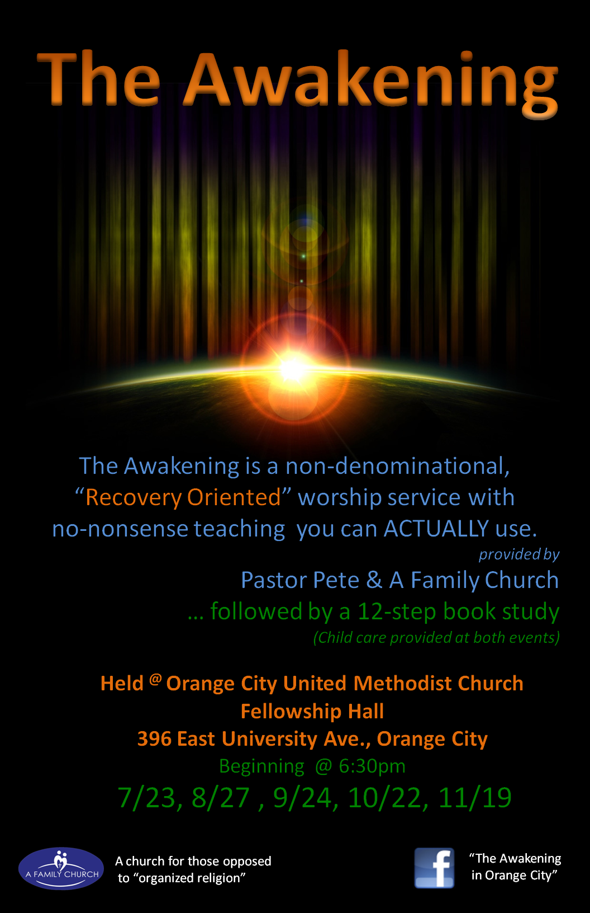

The Vision
The Awakening exists to bridge the cultural divide that exists between the Church and the addict. The Awakening is an extension campus of A Family Church and as such, exists to invite the un-churched into a relationship with Christ, disciple them to maturity and equip them for His service.
The Need
There are numerous 12-step meetings in the Orange City area. Thankfully so, because there is a growing epidemic of narcotic pills sweeping our nation. As one Narcotics Anonymous member with 10+ years clean & sober noted, “I’ve not seen anything like it. Most of the meetings I go to just keep getting bigger. The pill problem is filing up every meeting”.
There are plenty of churches in Orange City, FL and although most of them open their doors to all people (even those in recovery) few churches, if any, have an intimate understanding of recovery and unfortunately most are opposed to the very thing the recovering addict holds so valued (the 12 steps) because the program is not Christian. Thus, many addicts admit that if they do enter the doors of a church, they are skeptical and wonder, “Can these people understand me? Will they judge me for my past? Could I ever fit in here?”
Granted, there are many churches with recovery ministries as side notes to their main worship experience, but there are few, if any, churches that are totally and completely “Recovery Churches”.
The Opportunity
This is why “The Awakening” has the potential to be such a powerful movement. It is first of all a “recovery friendly” church service geared towards the addict and alcoholic. What makes it recovery friendly, one might ask? The teaching messages are very practical, using words, phrases and quotes that the addict has learned in 12-step meetings. Much like the apostle Paul quoted Greek poets to reach his audience on Mars Hill (Acts 17:28), so the literature of the 12-steps will be seamlessly intertwined with the Bible. By no means will the Word of God be reduced, but rather the packaging will be modified to reach a new audience of recovery minded, un-churched seekers. In fact, even the name “The Awakening” is a bridge between the recovery world and the church world. It is a direct quote of step 12 and it is also a throwback to the “Great Awakening”, one of the 1st and greatest revivals of the American continent, sparked by Jonathan’s Edwards famous sermon “Sinners in the hands of an angry God”.
To pull these messages together, God has prepared Pete Keirstead his whole life. Pete had struggles with alcohol as well as a suicide attempt as a young man. Yet, God intervened and at 20 yrs old, Pete gave his life to Christ. Since that time God has done a wonderful work healing and preparing Pete for such a time as this.
Now, two decades later, “Pastor Pete” is an ordained minister and founder of A Family Church (AFC). AFC is a church that started in a living room and now averages approximately 140 in weekly attendance. This year alone, AFC has recorded 84 decisions for Christ. Pete has worked in the substance abuse field, managing a 50-bed residential treatment facility as well as a 20 bed co-ed facility. His ministry sponsored a half-way house for people in recovery and he is also a licensed mental health therapist. A Family Church has been a long time friend of the 12-step community in Daytona Beach, hosting as many as six 12-step meetings per week. In addition, he worked in the Deland/ Orange City area for several years and has good contacts in the community.
The Strategic Aim: To successfully launch a new, “Recovery Friendly” church in Orange City, FL on Saturday evening, the 7th of January, 2012 with 100 adults in average weekly attendance the month of January.
Major Objective 1: Preparation (Before July 23, 2011)
- Order promotional Handouts
- Goals: hand out 300 invites
- Post 30 Posters
- Develop the necessary committees
- “Welcome team” usher greeter
- Finance Committee
- Follow up & data entry
- Activities committee to plan “come back events” that are both familiar & fun
- Children’s Ministry
- Raise 100 face-book friends
- Develop a bulletin shell and get copies made
- Raise $300
Major Objective 2: Pre-launch between July 23 and November 19, 2011
- Goals: Hand out 700 invites
- Post 70 posters
- Develop Systems
  - Volunteer system
  - Outreach system
  - Follow-up system
- Raise 500 face-book friends
- Plan a Christmas Eve candle-light service @ 8:30pm
- Find a location for weekly meetings and an office within $800 per month ( beginning Jan. 2012)
- Develop additional launch committees
  - Promotions
  - Technical/ worship
  - Raise $700
Major Objective 3: Launch Day (Saturday, January 7, 2012)
- Hand out 2500 Invites to Launch Sunday between November 19, 2011 and January 7, 2012
- Raise 1 year of monthly support commitments totaling $2000 monthly
- Goal of 200 in attendance

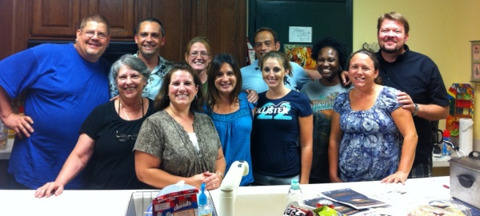
Updates as of 7/26/11
- Launch team developed
- 600 promotional invites have been handed out
- Commitment from 3 substance centers to have an open door to entrance into their facility and provide transportation to the services & meetings
- A Sneak peak service was held on 7/9/11 as a dress rehearsal
  - 48 in attendance
  - 8 decisions for Christ
  - 4 requests for baptism
  - Follow-up on those in attendance resulted in __ % returning to our 1st preview service
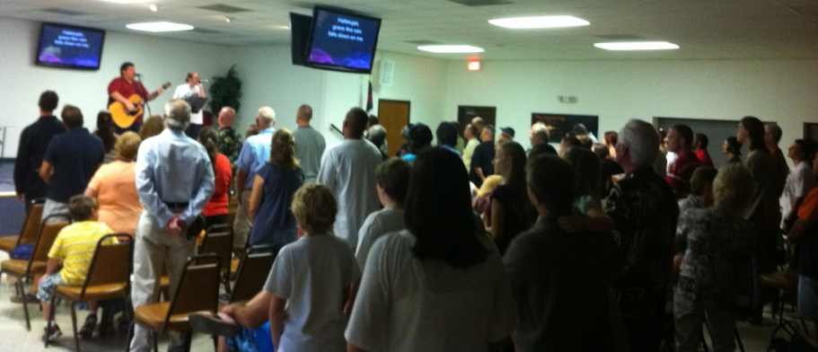
- 1st Preview service held on 7/23/11
  - 98 in attendance
  - 20 decisions for Christ
  - 14 requests for baptism
  - The meeting that followed discussed how to implement the sermon’s main point & scripture into a lifestyle of recovery . We had 51 in attendance.
- Follow-up system in place
- 9 Sponsors of the 25 desired sponsors making a minimum commitment of $100 of monthly support
  - The Keirstead Family
  - A Family Church, Daytona
  - The Tillinghast Family
  - The Baum Family
  - The Pawlak Family
  - Mark Miranda
  - Tabitha Grimes
  - Christi Lee Ross
  - Rebecca Marketill
- Potentially located a bi-vocational campus pastor
  - He is beginning the interview/ application process
- Children’s ministry director in place
- Comeback event planned
  - Couples seminar “Healthy love & relationships”

2012 Monthly budget Expenses | $3100
Facilities
Sanctuary rent (school) | $1300.00
Office | $200.00
Elect | $ 50.00
total | $1550.00
Staffing
Bi-Voc Pastor | $400.00
Bi-voc Worship | $200.00
Total | $600.00
Missions
ARC | $62
Savings (Future plant) | $62
Awakening Network | $62
Other Intl. Missions | $124
Total | $310
Office
Supplies | $155.00
Copies | $ 46.50
Bulletins | $ 31.00
Congregational gifts | $ 31.00
Creative Arts | $ 15.50
Ministries
Music | $ 62.00
Youth | $ 31.00
Children | $ 31.00
Outreach | $ 217.00
Misc. | $ 15.50
Total | $635.50
Projected Monthly Income 2012 $3300
- 25 sponsors for 2012 $2500
- Offerings $800
- Surplus goes into a savings pool for equipment. We are truly starting from scratch, borrowing all audio/ visual equipment, computers, etc. from the Orange City United Methodist Church and A Family Church, Daytona Beach. Within a year we will have to begin making purchases.

